**HUMAN-ROBOT TOUCH INTERACTION EXPERIMENT PROTOCOL**

# Informed consent

This informed consent form is intended for individuals who are invited to participate voluntarily.

## Resume of investigation:

Name of the investigation: BART tasks

Principal investigator: Qiaoqiao Ren

Participating entities: Ghent university

## Resume of participants:

Name:

Gender:

Profession:

Age：

This Informed Consent document has two parts:

1 Information about the study

2 Consent Form to sign if you agree to participate

# Part I: Information

## Introduction

These informed consent sheets may contain words that you do not understand. Please ask the principal investigator or anyone in the study to explain any words or information that you do not clearly understand. You will be given a copy of the completed informed consent document.

## Purpose

### Type of study and general design

#### Research aims

We used an intervention study in this research. The goal of intervention studies is to test the impact of human-robot touch in promoting the human risk-taking behavior, truth, happiness state, and physical arousal by assigning different robot touching behaviors.

#### Statement of the research hypothesis

1 Touching a robot will promote risk-taking behavior

2 High-intensity touch promote an increase more risk-taking than light intensity touch

3 More risks will be taken in the presence of a robot

4 Heart rate has a positive correlation with skin conductivity for arousal level.

5 Touching a robot will promote Heart rate

6 High-intensity touch promote heart rate than light intensity touch

7 High-intensity touch promotes skin conductivity than light intensity touch

8 Happiness state: Touching a robot will promote a happier state.

9 Touching robots can increase human trust in robots

10 Touching robots promote heart rate arousal and synchrony

11 Trust has an effect on heart rate arousal and synchrony

12 High-intensity touch promotes increased trust in the robot in a robot that light intensity touch

13 High-intensity touch makes more heart rate arousal.

#### Justification and use of results

The result could be collected and analyzed to compare differences among the experimental groups.

## Selection of participant

Your participation in this research is completely voluntary, and they also meet the inclusive criteria and not be included in the exclusive criteria scope. You can choose to participate or not. Whether you choose to participate or not, all services you receive at this facility will continue, and nothing will change. You can change your mind later and stop participating even if you agreed earlier.

## Exclusion and Inclusive criteria

The exclusive and inclusive criteria are given below to ensure that the experiment succeeds and gains good results and avoid any interference with the study's success or increasing the risk of an unfavorable outcome.

|  |  |
| --- | --- |
| Inclusive and exclusive criteria for a human-robot touch study | |
| Inclusive criteria | Exclusive criteria |
| Adults>=18 years old | Refusal to give informed consent |
| Able to consent | Diagnosis of reading and listening disorders or any other heart disease |
|  | Any acute or chronic condition that would limit the ability of the patient to participate in the study |

## Methodology

The game instruction is given below:

### Language setting :

This game has Dutch and English versions, what's more, the nao robot could also speak Dutch and English, and you can choose your preferred language set.

### Procedures:

Please follow the procedure below one by one.

1. Language setting: Choose your preferred language at the right bottom by clicking a different button; the top button is "dutch," and the bottom one is "English."

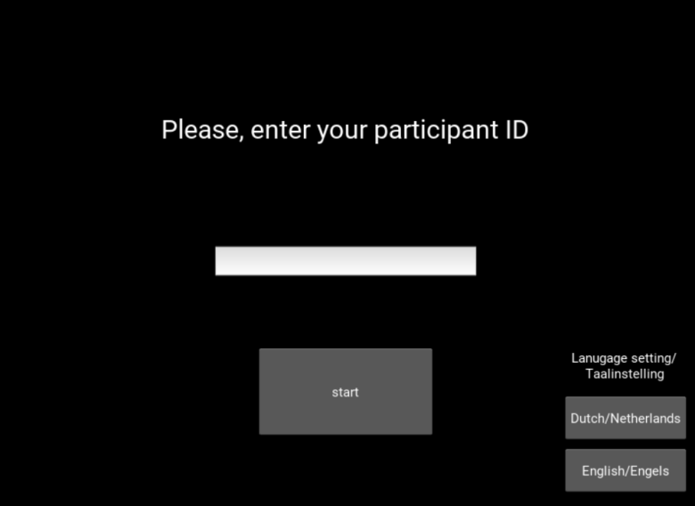

1. Please input your participant's ID, which is on the note distributed to you before. 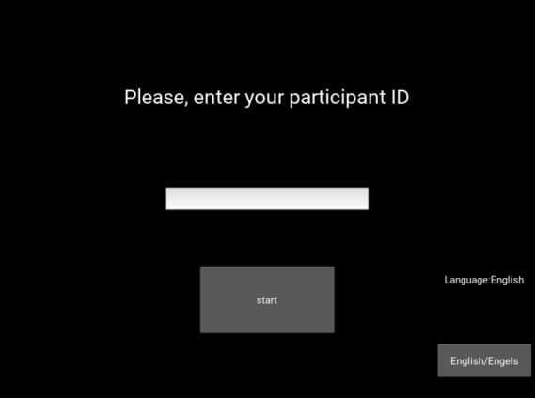 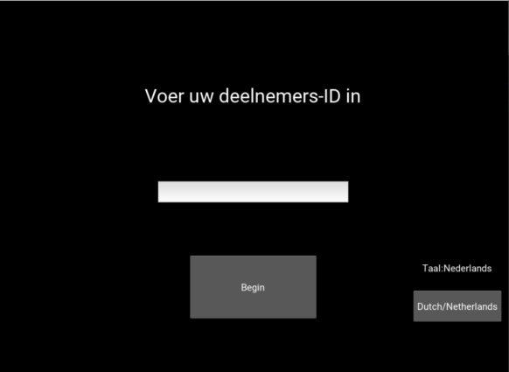
2. Follow the instruction on the screen and then press the start button to start the game.

### Brief introduction:

Before you start the game, the robot will give you a brief introduction of this game; also, the text version of the robot said will display on the screen to make sure that you won't miss anything. If you forget the rules or miss some content of the introduction, you could still press the "rules" button to know the detailed rules of this game.

### The explanation of the game :

Participants were going to see 30 air balloons, one after the other; during 30 trials, participants were asked to press the 'pump balloon' button to inflate a balloon displayed on the computer monitor. You can pump at most 127 times. Be careful! Balloons can pop at any time! Some might even pop after a single pump. Each pump is worth 0.01 euro: the more you pump, the more you earn! In total, thus, participants inflated 30 different balloons, the balloon was inflated by 1, and 1 cent (Europe currency) was added to the participant's "temporary piggy money bank," which was shown on the screen. This represented the sum earnings for the current balloon. After each pump, a "collect reward" button displayed on the screen could be clicked by the participant to "cash in" the winnings for the current balloon. By clicking the button, the participant moved on immediately to the next balloon, and the winnings for the previous balloon were added to the participant's overall earnings, also displayed on the screen. If the balloon exploded after a pump was made, all winnings for that balloon were lost, and participants moved on to the next balloon without adding to their overall earnings. We'll pay the money you earned in cash at the end of the game.

Attention: the participants can also quit the game by the "quit" button. The participants won't earn any money if they quit before the end of the game.

### Questionnaire

After the game, participants will be brought to another room to fill out two questionnaires, one is about happiness state, and another is about trust.

#### As for happiness :

As for happiness state:

1)Mark the robot's different feelings from your perspective

1)Mark your feeling

#### Trust questionnaire

PERFORMANCE TRUST

Reliable Subscale: reliable, predictable, dependable, consistent

Competent Subscale: competent, skilled, capable, meticulous

MORAL TRUST

Ethical Subscale: ethical, principled, moral, has integrity

Transparent Subscale: transparent, genuine, sincere, candid

Benevolent Subscale: benevolent, kind, considerate, has goodwill

## Equipment and facilities

Laptop and Nao robot, Nao is a small humanoid robot designed to interact with people. It's packed with sensors (and character), and it can walk, dance, speak, and recognize faces and objects.

### Nao robot:

You will see one robot in this experiment. It has been set in three modes. Enjoy the game with them.

##### Mode 1

In this game, you will have one partner to accomplish this game with you. You can see him on the desk. Yes, he is a robot. He will try to play this game with you together, sometimes, he will ask you to have some interaction with him, such as high-five, shake hands, and he might hope you to stroke his head, please give him some responses, have fun with Nao.

##### Mode 2

In this game, you will have one partner to accomplish this game with you, you can see him on the desk, yes, he is a robot, and he will try to play this game with you together. Please put him on your lap after he gives you a brief introduction to the game. Therefore they could see what you are doing and then play the game with you together.

Note: Please be careful, take care of the robot's arm, and try to avoid disturbing this robot's arm when he is moving.

##### Mode 3

In this game, you will have one partner to accomplish this game with you, you can see him on the desk, yes, he is a robot, and he will try to play this game with you together and have fun with Nao.

## Procedures and Protocol

### Duration

The experiments consist of 4 sub-tasks. Each subtask takes ten minutes. It takes 40 minutes to finish the whole task.

### Methodology

You will be taken into the robot testing room to attend to different tasks. After you finish the tasks, the principals will ask you to get into another room to fill in the questionnaire.

### Risks

Be careful of the robot's movement. If you find the robot out of control or did some strange behavior, please ask the principal for help. Also, if you feel uncomfortable or have some health issues during the test, please abort the game and ask the principal for assistance.

### Benefits

You will receive particular money in return as the benefit of attending the experiment,

incentives

### Confidentiality

All study-related information will be stored securely at the study site. All participant information will be stored in locked file cabinets in areas with limited access. All laboratory questionnaires, reports, data collection, process, and administrative forms will be identified by a coded ID [identification] number only to maintain participant confidentiality. All records that contain names or other personal identifiers, such as locator forms and informed consent forms, will be stored separately from study records identified by code number. All local databases will be secured with password-protected access systems. Forms, lists, logbooks, appointment books, and other listings that link participant ID numbers to add identifying information will be stored in a separate, locked file in an area with limited access.

### Sharing the Results

The participants could not gain some direct benefits from this experiment, but it might have some advantages for other research and promote the technology development; therefore, the result data could be shared with other researchers.

### Right to refuse or withdraw

An individual who initially agrees to participate in a study has the right to withdraw from the study at any point and the right to refuse to answer any particular question(s) or participate in a particular set of procedures. Thus, the voluntary quality of participation is protected at three points in a study: initial enrollment, continuation in the study, and the right to refuse to answer specific questions or participate in a study procedure. To ensure voluntary participation at each of these points, investigators develop approaches to recruiting participants that are not coercive and that provide full disclosure of all study procedures.

### Who to Contact

If you have any problems or any questions, please contace Qiaoqiao Ren, the email address is: Qiaoqiao.ren@ugent.be

# Part II: Consent Form

I,

identified with citizenship card number:

I have read and understood this document and that my questions have been answered satisfactorily; therefore, I give my informed consent to participate in the research called "BART TASKS." I agree that my name, age, and other information anthropometric data are stored. I know that I can withdraw from the experiment at any time.

Participating Subject:

Name:

Direction:

Phone:

Signature ID: Identification card:

## Investigator statement

I certify that I have explained to this person the nature and purpose of the research and that this person understands his or her participation and the possible risks and benefits involved. All the questions that this person has asked have been answered adequately. Likewise, I have read and adequately explained the parts of the informed consent. I certify with my signature.

Investigator:

Name:

Identification card:

Investigator Signature: Date (yyyy/mm/dd):

**Flow Chart of the experimental design**

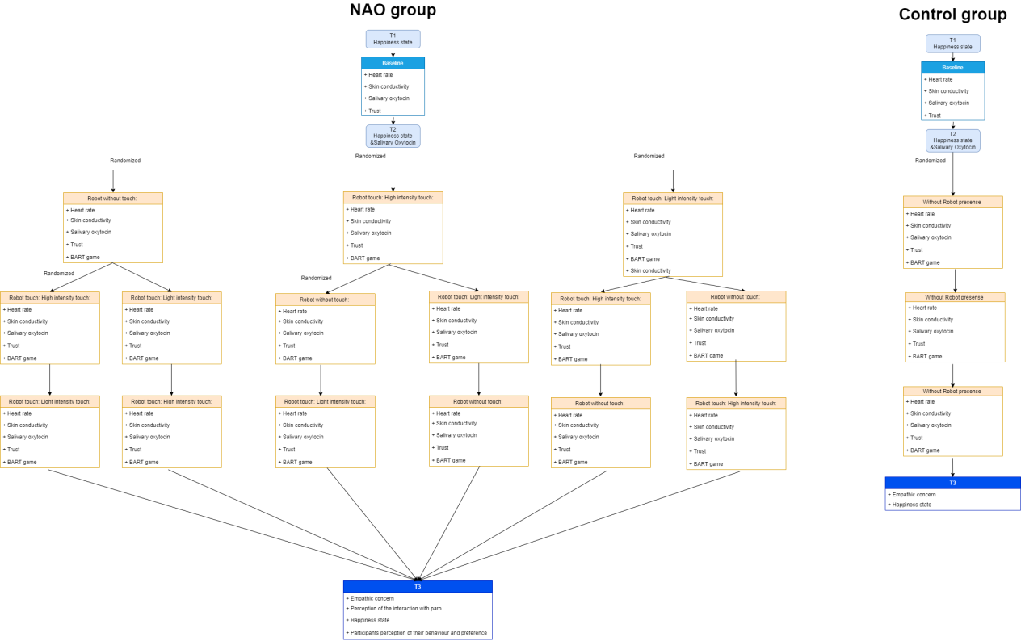

**How to design this experiment?**

1 Some research indicates that men tend to be more likely to be risk-takers than women.2 reBut both male and female risk-takers share the same personality traits, such as impulsive sensation-seeking, aggression-hostility, and sociability, one study found.3

Byrnes J, Miller D, Schafer W. [Gender differences in risk taking: A meta-analysis](https://doi.org/10.1037/0033-2909.125.3.367" \t "https://www.verywellmind.com/_blank). Psychol Bull. 1999;125:367-383. doi:10.1037/0033-2909.125.3.367

Zuckerman M, Kuhlman DM. [Personality and risk-taking: common biosocial factors](https://doi.org/10.1111/1467-6494.00124" \t "https://www.verywellmind.com/_blank). J Pers. 2000;68(6):999–1029. doi:10.1111/1467-6494.00124

1 Touching a robot will promote risk-taking behavior

2 High-intensity touch promote an increase more risk-taking than light intensity touch

3 More risks will be taken in the presence of a robot

4 Heart rate has a positive correlation with skin conductivity for arousal level.

Physiological arousal;Measurement of Arousal: At somewhat longer intervals are the autonomic measures of Skin Conductance (SC) and Heart Rate (HR).

5 Touching a robot will promote Heart rate

6 High-intensity touch promote heart rate than light intensity touch

7 High-intensity touch promotes skin conductivity than light intensity touch

8 Happiness state: Touching a robot will promote a happier state.

Risk-taking behaviour will promote a happier state

9 Touching robots can increase human trust in robots

|  |  |  |  |  |  |
| --- | --- | --- | --- | --- | --- |
|  | Reliable Subscale | Competent Subscale | Benevolent Subscale | Transparent Subscale | Ethical Subscale |
| Group 1 |  |  |  |  |  |
| Group 2 |  |  |  |  |  |
| Group 3 |  |  |  |  |  |
| Group 4 |  |  |  |  |  |

10 Touching robots promote heart rate arousal

11 Trust has an effect on heart rate arousal

12 High-intensity touch promotes increased trust in the robot in a robot that light intensity touch

13 High-intensity touch makes more heart rate arousal

14 Male participants will risking more than female participants in BART games

|  |  |  |
| --- | --- | --- |
|  | Male’s BART game’s scores | Female’s BART game’s scores |
| Group 1 |  |  |
| Group 2 |  |  |
| Group 3 |  |  |
| Group 4 |  |  |

Results:

Participants’ perceptions of the interaction with NAO

The effect of the interaction with NAO on the participants’ emotional state.

The effect of the interaction with NAO on salivary oxytocin levels.

The effect of the interaction with NAO on BART game scores.

The effect of the interaction with NAO on the participants’ physiological arousal(skin conductivity and heart rate)

The effect of the interaction with NAO on the participants’ trust.

The relationship between trust, risk and arousal

The relationship between risk-taking behaviour and empathy

Measurement:

1 BART score

2 Empathic concern

3 Participants’ Perception of the interaction with nao

4 Heart rate

5 Skin conductivity

6 Trust

7 Happiness state

8 Salivary oxytocin

9 Self-reported risk-taking

10 Perception of the interaction with nao

**Sample size for experiment group**

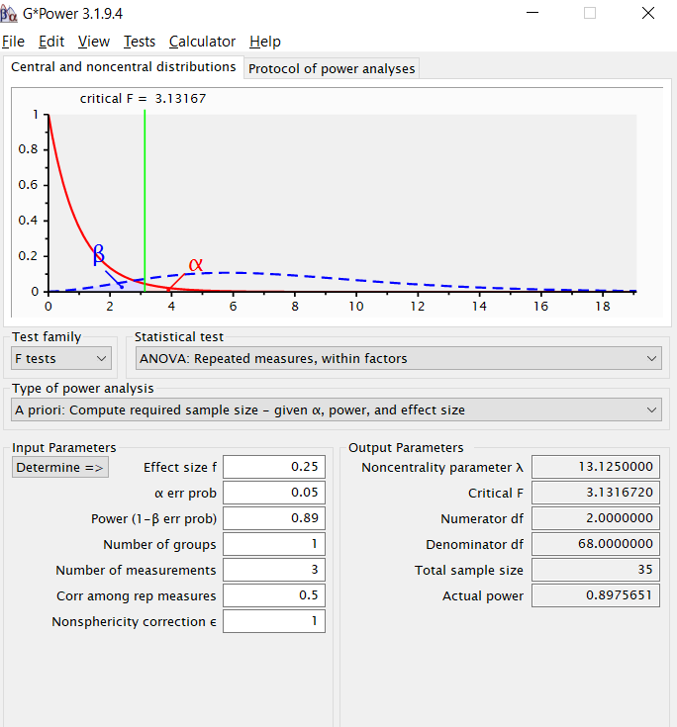

Simple size for control group

10 person

***Reaped measure ANOVA test***

|  |  |  |  |  |  |  |  |  |  |
| --- | --- | --- | --- | --- | --- | --- | --- | --- | --- |
|  | BART scores | Self-reported risk-taking | Perception of the interaction with nao | Salivary oxytocin | Trust | Happiness state | Empathic concern | Skin conductivity | Heart rate |
| Group 1 |  |  |  |  |  |  |  |  |  |
| Group 2 |  |  |  |  |  |  |  |  |  |
| Group 3 |  |  |  |  |  |  |  |  |  |
| Group 4 |  |  |  |  |  |  |  |  |  |

***chi-square test***

Male participants will take more risk-taking behaviour than female participants.

|  |  |  |
| --- | --- | --- |
|  | Male’s participant score | Female’s participant score |
| Group 1 |  |  |
| Group 2 |  |  |
| Group 3 |  |  |
| Group 4 |  |  |

Correlation experiment

1 BART score

Empathic concern

Perception of the interaction with nao

Heart rate

Skin conductivity

Trust

Happiness state

Salivary oxytocin

Self-reported risk-taking

|  |  |  |  |  |  |  |  |  |  |
| --- | --- | --- | --- | --- | --- | --- | --- | --- | --- |
|  | BART scores | Self-reported risk-taking | Perception of the interaction with nao | Salivary oxytocin | Trust | Happiness state | Empathic concern | Skin conductivity | Heart rate |
| Group 1 |  |  |  |  |  |  |  |  |  |
| Group 2 |  |  |  |  |  |  |  |  |  |
| Group 3 |  |  |  |  |  |  |  |  |  |
| Group 4 |  |  |  |  |  |  |  |  |  |

2 Happiness state

The participant’s feeling

Heart rate

Skin conductivity

|  |  |  |  |  |  |  |
| --- | --- | --- | --- | --- | --- | --- |
|  | Happiness state | The participant’s feeling | Heart rate | Skin conductivity | Salivary oxytocin | Empathic concern |
| Group 1 |  |  |  |  |  |  |
| Group 2 |  |  |  |  |  |  |
| Group 3 |  |  |  |  |  |  |
| Group 4 |  |  |  |  |  |  |

Empathic concern

Bonferroni correction;p

3 Trust

Empathic concern

Heart rate

Skin conductivity

Happiness state

Salivary oxytocin

|  |  |  |  |  |  |  |
| --- | --- | --- | --- | --- | --- | --- |
|  | Trust | Heart rate | Skin conductivity | Salivary oxytocin | Happiness state | Empathic concern |
| Group 1 |  |  |  |  |  |  |
| Group 2 |  |  |  |  |  |  |
| Group 3 |  |  |  |  |  |  |
| Group 4 |  |  |  |  |  |  |

4 Empathic concern

The participant’s willing to touch robot

|  |  |  |
| --- | --- | --- |
|  | Empathic concern | The participant’s willing to touch robot |
| Group 1 |  |  |
| Group 2 |  |  |
| Group 3 |  |  |
| Group 4 |  |  |